Investigating Trends in Neglected Tropical Disease (NTD) Clinical Studies

Group ID:16
Project Title: Investigating Trends in Neglected Tropical Disease (NTD) Clinical Studies
Project Host: Infectious Diseases Data Observatory, University of Oxford
Organisation Name: Infectious Diseases Data Observatory, University of Oxford
Main contact Name: Rhys Peploe
Main contact Position: Statistician
Document Type: Project Report
Team Members:
Peizhe Jiang
Lancaster University, p.jiang6@lancaster.ac.uk

Congyao Ren
Lancaster University, c.ren1@lancaster.ac.uk
Zixu Wang
Lancaster University, z.wang120@lancaster.ac.uk

Alaghwani Balsam
Lancaster University, b.alaghwani@lancaster.ac.uk

This project analyses clinical trial data on Neglected Tropical Diseases (NTDs) from the WHO International Clinical Trials Registry Platform (1999–2023). Four diseases — Chagas disease, Schistosomiasis, Soil-transmitted helminthiases, and Visceral leishmaniasis — were examined. Using data cleaning, logistic regression, network analysis, and text mining, the study explores sponsor patterns, result disclosure, collaboration networks, and drug trends. Findings show limited industry involvement and low result transparency, highlighting structural imbalances in global NTD research.
Keywords: Neglected Tropical Diseases, Clinical Trials, Logistic Regression, Network Analysis, Data Mining, WHO ICTRP

- Introduce
  - Project Background and Research Motivation
Neglected Tropical Diseases (NTDs) have long seriously threatened the health of more than a billion people around the world[1], especially in areas with poor socio-economic conditions. However, compared with its huge burden of disease, NTDs-related research and funding are still seriously insufficient. Based on the clinical trial data of the International Clinical Trials Registry Platform (ICTRP) of the World Health Organization (WHO) from 1999 to 2023, this project systematically analyzes four types of key diseases - Chagas disease, Schistosomiasis, Soil-transmitted helminthiases and Visceral leishmaniasis.
This study aims to reveal the distribution characteristics and potential imbalances of global NTDs research through quantitative exploration of the types of trials, disclosure of results, inter-country cooperation networks and drug research trends, so as to provide data support for the allocation of scientific research resources and policy formulation.
  - Research Questions
In order to ensure that the research objectives are clear and measurable, this project revolves around the following four core issues:
RQ1: Sponsorship pattern - What is the distribution of sponsors of different categories (government, industry, non-profit organizations, etc.) in all clinical trials and trials with published results?
RQ2: Results Release Factors - Which experimental attributes (research stage, research type, sponsor category, national income level) are related to the release (or not released) of the test results?
RQ3: International Cooperation Network - Which countries are at the center of the clinical research cooperation network? Is there a difference in the distribution of industry-funded experiments in countries with a high disease burden?
RQ4: Drug research trends (take Chagas disease as an example) - Which drugs have been frequently studied in different periods? How does its research trend evolve in the time dimension?
RQ5: Are children and pregnant women included or excluded from studies, and how does this vary by disease or study phase?
  - Research Objectives and Expected Results
In order to answer the above questions, this project sets the following specific goals[3]:
    - Data cleaning and construction: extract and sort out core variables from ICTRP raw data to form a clean data set that can be analyzed.
    - Descriptive analysis: statistics and visualization of the distribution of different sponsorship categories in the overall and "published" subsets.
    - Logical regression modeling: take "whether the results are released" as the dependent variable to study the impact of experimental attributes (stage, type, sponsor, income level) on the release of results.
    - Cooperative network analysis: build a multi-country cooperation network, calculate the degree-centricity and intermediary-centricity of countries, and compare the industrial funding of countries with high disease burden and non-high-burden countries.
    - Drug trend analysis: for Chagas disease, extract and count drug names, and analyze the annual frequency of different drugs between 1999 and 2023.
    - Limitations and suggestions for improvement: summarize problems such as data deviation, missing fields and model assumptions, and put forward the direction of improvement for future research

  - Overview of Methodology and Findings
The research first cleans and standardizes the original ICTRP data, and then carries out four types of analysis[3]:
- descriptive statistics of sponsor type distribution;
- the influencing factors of the logical regression model to explore the results;
- the central analysis of the multi-country cooperation network;
- the extraction and visualization of drug research trends for Chagas disease.
Preliminary results show that the proportion of experiments sponsored by non-profit organizations accounts for about 67%, and the industry accounts for only about 7%; only about 4% of the experiments released results, showing that information transparency is insufficient.
The cooperative network is centered on a few countries, and the industrial participation in high-burden areas is low. The study of Chagas disease is concentrated on a few drugs (such as Benznidazole, E1224), and the time distribution fluctuates in stages[4]. These results reveal the significant imbalance in the sponsorship structure and knowledge disclosure of the current NTDs clinical research[5], and provide a reference basis for follow-up policy interventions and resource allocation.
- Methodology
  - Research Strategy
This study adopts the strategy of combining quantitative data analysis and data mining to systematically explore the structural characteristics and result release laws of neglected tropical disease (NTDs) clinical trials [3]. The research follows the CRISP-DM (Cross Industry Standard Process for Data Mining) process [6], including:
    - Problem understanding: clarify four research questions (RQ1–RQ4) and define the research objectives;
    - Data understanding and preparation: export NTDs-related test data from the WHO ICTRP platform and clean it;
    - Modeling and analysis: using descriptive statistics, logical regression models, network analysis and text mining;
    - Evaluation and interpretation: Verify and reflect on the research problems in combination with charts and model results. This strategy can effectively integrate statistical inference and visual analysis to ensure that the conclusion is interpretable and reproducible.
  - Data Collection, Cleaning and Preprocessing
    - Data source
The original data comes from the WHO International Clinical Trials Registry Platform (ICTRP) of the World Health Organization.
A total of 315 records (1999–2023), involving four types of key diseases:
Chagas disease, Schistosomiasis, Soil-transmitted helminthiases,And Visceral leishmaniasis.
    - Cleaning process
Data cleaning is implemented using Python (Pandas, NumPy)[7], and the core steps include:
Field filtering: retain the characteristics related to the research problem (research stage, research type, sponsor category, income level, result release status, etc.), and delete irrelevant fields (such as contact information, web links, etc.).
Missing value processing: fill in the missing value of the sample volume with the medin (286); delete the record of seriously missing information (4).
Text normalization: unify case and remove HTML tags and abnormal symbols.
Sponsor classification: Sponsors are divided into Government, Industry, Non-profit and Other according to keywords (such as university, ministry, pharma)[8].
Time and country verification: ensure that the test time and the country field are valid.
Finally, 311 valid records were obtained and saved as (CleanedData/cleaned_ictrp.csv).At the same time, generate several derived data tables (such as country_statistics.csv, network_statistics.csv, chagas_drug_trends.csv) for subsequent analysis.
    - Feature coding and preprocessing
In order to facilitate logical regression modeling, One-Hot Encoding is carried out on four classification features (phase, study_type, sponsor_category, income_level).Coding is implemented through OneHotEncoder(handle_unknown='ignore')[9] and integrated into ColumnTransformer and Pipeline, Ensure the integration of preprocessing and model training, and be able to automatically process unknown categories.
  - Data Analysis and Modeling
    - Descriptive analysis
In order to provide a macro-level understanding of the research problems RQ1 and RQ4,this section first conducts a descriptive statistical analysis of NTD clinical trials from the two perspectives of geographical distribution and sponsor distribution.
We first show the geographical distribution map of the number of global experiments to outline the differences in overall research activities between different countries.
Figure 1 shows the distribution heat map of NTD clinical trials worldwide from 1999 to 2023. It can be clearly seen that the trials are mainly concentrated in countries such as Brazil,Argentina,India and China,while there are relatively few research activities in many high-burden African countries.

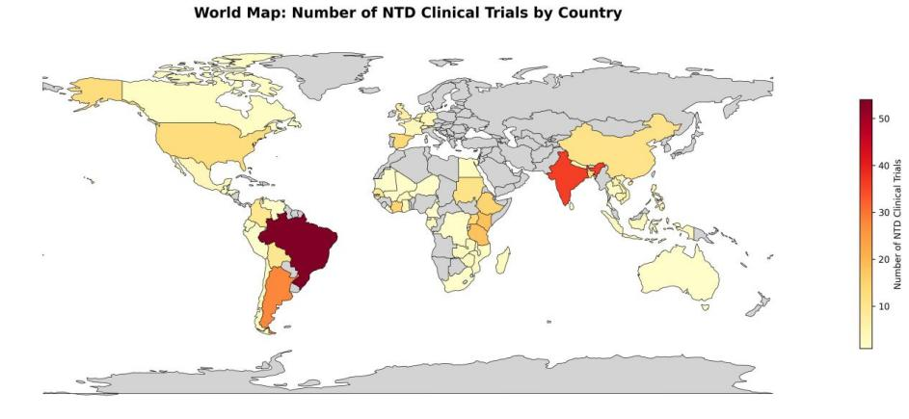
Figure1 Global Distribution of NTD Clinical Trials (1999–2023)(CleanedDataPlt/world_heatmap.jpg)
According to the WHO Global NTD report,the global burden of neglected tropical diseases is highly concentrated in a few countries:India, Nigeria and Indonesia together account for more than 50% of the global population in need of intervention, while the top 15 countries contribute more than 80% of the global burden [1].The clinical trials in this research data mainly come from Brazil, Argentina, India, China and other countries, which are highly consistent with these global high-burden countries. Therefore, the geographical concentration of the experiment reflects the structural distribution of high-burden sources of global NTD, not the data bias.
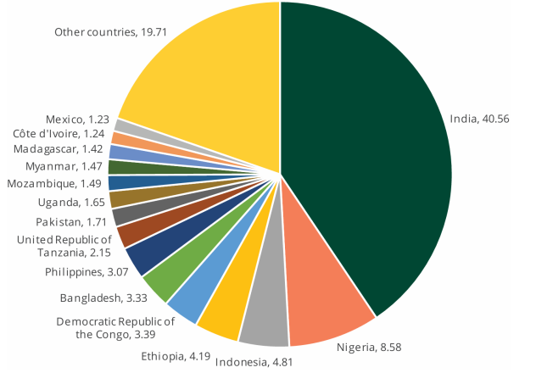
Figure2 [13] Proportion (%) of people requiring interventions against NTDs, by country, 2022(https://www.who.int/publications/i/item/9789240091535)

After establishing this geographical overview, we analyse sponsor composition and result release patterns.
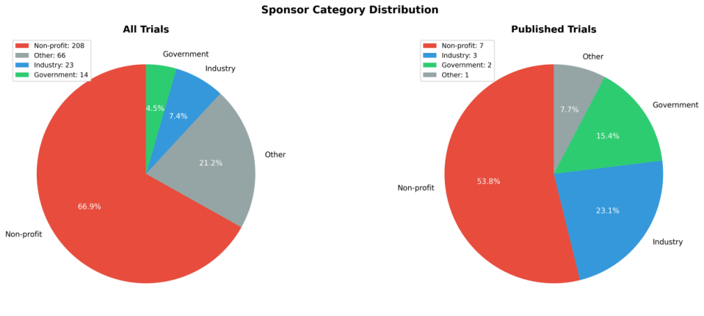
Figure 3 Sponsor Category Distribution(CleanedDataPlt/sponsor_distribution.jpg)
Figure 3 shows the distribution of sponsor categories, followed by calculations of the proportion of released results, differences across sponsor types, and comparisons between high-burden and non–high-burden countries
    - Logistic Regression
In order to explore the impact of experimental attributes on the release of results (RQ2), we employ a Logistic Regression classification model [10], which is particularly suitable for binary outcomes and provides clear interpretability by quantifying the direction and magnitude of each feature’s influence on the likelihood of result disclosure[10].
$$\text{P}\text{(}\text{results}\text{\backslash _}\text{posted}\text{=1)=}\text{σ}\text{(}{\text{β}}_{\text{0}}\text{+}\sum_{\text{i}}{{\text{β}}_{\text{i}}}{\text{X}}_{\text{i}}\text{)}$$
Among them, represents the features after one-hot encoding.
The model parameters are set to: the maximum number of iterations max_iter=2000, and the solver solver='lbfgs'.
The output includes: regression coefficient β, odds (Odds Ratio = e^β),
Model accuracy rate (about 0.85).
Export the results to CleanedData/logit_results.csv, and draw a grouped bar chart to show the direction of influence of each feature
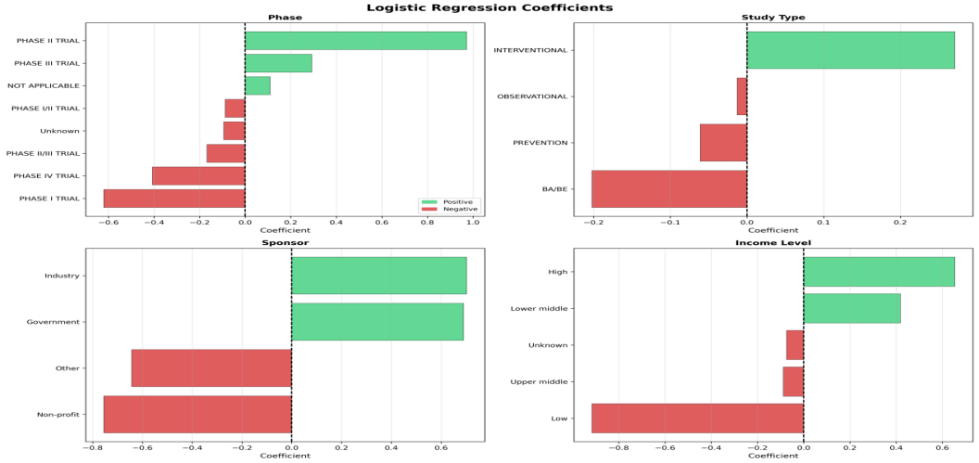
Figure4 Logistic Regression Coefficients(CleanedDataPlt/coefficients_plot.png)
    - Network Analysis
In order to study the cooperation between countries (RQ3), this study uses NetworkX to build a national cooperation network [11]. In the network, the node represents the country, and the side indicates that the two countries have appeared together in the same clinical trial, so it can be regarded as a cooperative relationship.
In order to identify countries with an important position in the cooperative network, we calculated the Betweenness Centrality, which is defined as follows:
$${\text{C}}_{\text{B}}\text{(}\text{v}\text{)=}\sum_{\text{s}\text{≠}\text{v}\text{≠}\text{t}}{\frac{{\text{σ}}_{\text{st}}\text{(}\text{v}\text{)}}{{\text{σ}}_{\text{st}}}}$$
In addition, we also calculated the Degree Centrality to measure the number of partners directly with each country.

Figure4 Network(waited)
Through these two central indicators, we can identify countries in critical positions in the cooperative network, such as Argentina, Brazil and Vietnam. All calculation results are exported to the network_statistics.csv.
    - Text Mining for Drug Trends
For Chagas disease (RQ4), use regular expressions to extract drug name fields (such as Benznidazole, E1224, Placebo, etc.),[12]
Count the annual research frequency of different drugs and generate a line chart

Figure5 chagas_drug_trends line chart(waited created )
The analysis reveals the time trend and research concentration of drug research and development.

- Reference
- World Health Organisation. 2025. Global Report on Neglected Tropical Diseases 2025. Retrieved from https://www.who.int/teams/control-of-neglected-tropical-diseases/global-report-on-neglected-tropical-diseases-2025
- N. Feasey, M. Wansbrough-Jones, D. C. W. Mabey, and A. W. Solomon, “Neglected tropical diseases,” British Medical Bulletin, vol. 93, no. 1, pp. 179–200, Mar. 2010. [Online]. Available: https://doi.org/10.1093/bmb/ldp046
- J. Han, M. Kamber, and J. Pei, Data Mining: Concepts and Techniques, 4th ed. Amsterdam: Elsevier, 2023.Available:https://www.elsevier.com/books/data-mining/han/978-0-12-811760-6
- J. A. Pérez-Molina and I. Molina, “Chagas disease,” The Lancet, vol. 391, no. 10115, pp. 82–94, 2018. [Online]. Available: https://doi.org/10.1016/S0140-6736(17)31612-4
- Bourgeois et al. (2010). BMJ — Clinical trial result reporting & transparenchttps://www.bmj.com/content/341/bmj.c4753
- P. Chapman, J. Clinton, R. Kerber, T. Khabaza, T. Reinartz, C. Shearer, and R. Wirth, CRISP-DM 1.0: Step-by-step data mining guide, SPSS Inc., 2000. [Online]. Available:https://public.dhe.ibm.com/software/analytics/spss/documentation/modeler/14.2/es/CRISP-DM.pdf
- W. McKinney, Python for Data Analysis, 3rd ed. Beijing: O’Reilly Media, 2022. [Online]. Available: https://wesmckinney.com/book/
- Florence T. Bourgeois, S. Murthy, and Kenneth D. Mandl. 2010. Outcome reporting among drug trials registered in ClinicalTrials.gov. Annals of Internal Medicine, 153(3), 158–166. https://www.acpjournals.org/doi/10.7326/0003-4819-153-3-201008030-00006
- F. Pedregosa et al., “Scikit-learn: Machine learning in Python,” Journal of Machine Learning Research, vol. 12, pp. 2825–2830, 2011. [Online]. Available: https://jmlr.org/papers/v12/pedregosa11a.html
- D. W. Hosmer, S. Lemeshow, and R. X. Sturdivant, Applied Logistic Regression, 3rd ed. Hoboken, NJ: Wiley, 2013. [Online]. Available: https://www.wiley.com/en-us/Applied+Logistic+Regression%2C+3rd+Edition-p-9780470582473
- A. A. Hagberg, D. A. Schult, and P. J. Swart,
“Exploring network structure, dynamics, and function using NetworkX,”
Proceedings of the 7th Python in Science Conference (SciPy 2008), Pasadena, CA, USA, pp. 11–15, 2008.
[Online]. Available: https://networkx.org/
- C. D. Manning, P. Raghavan, and H. Schütze, Introduction to Information Retrieval. Cambridge: Cambridge University Press, 2008. [Online]. Available: https://nlp.stanford.edu/IR-book/
- World Health Organization. 2024. Global report on neglected tropical diseases 2024. World Health Organization, Geneva, Switzerland. ISBN 978-92-4-009153-5. Retrieved from https://www.who.int/publications/i/item/9789240091535

- Contributions Sheet
Group ID | : | 16
Project Title | : | Investigating Trends in Neglected Tropical Disease (NTD) Clinical Studies
Project Host | : | Infectious Diseases Data Observatory, University of Oxford

Group Member Contributions
Student Name | Student ID | Contribution/ Role Description | % Contribution

Confirmation of Agreement
Student ID | Signature | Date

